C950 WGUPS Algorithm Overview

Steven Bennett

ID #003761827

WGU Email: sben205@wgu.edu

March 20, 2023

C950 Data Structures and Algorithms II

# Introduction

Welcome to my C950 Project Assessment. The goal was to manage local delivery distribution for WGUPS (Western Governors University Parcel Service) operating in Salt Lake City, UT. Deliveries consisted of 40 packages utilizing 3 trucks and 2 drivers. Some packages had earlier delivery times, late arrival times, and/or other constraints. One package was assigned an incorrect address which had to be corrected at a specified time after the trucks began their route. A command line User Interface allows the user to get updates on one or all packages at a user specified time as well as an End of Day report that outputs all package data and all truck mileage. This documentation will explain the use of the nearest neighbor algorithm and provide an overview of application components.

# A. Algorithm Identification

The self-adjusting algorithm shortest_distance (line 128 of main.py) is based on the Nearest Neighbor algorithm.

# B1. Logic Comments

***** add distance_between and hash table pseudo

Here I will elaborate on how the program’s primary data structure self-adjusts to the number of packages, how the trucks are loaded by the auto_load_trucks function, and how the packages are delivered by the deliver_packages function.

For the hash table to function properly, the end user will provide clean and accurate package data, distance, and address data in the form of CSV files. In main.py, a chaining hash table object is created and the input_package_data function creates a package object from each row of package data in the corresponding CSV file. Then that package is inserted into the hash table. This process continues regardless of the number of packages. The data structure is dynamic and is proportionate to the number of packages. For this example, the initial capacity of the hash table is set manually and is equal to the number of packages which minimizes collisions.

# Pseudocode for input_package_data:

Open the CSV file containing package data

Create package_row using csv.reader built in using ‘,’ as delimiter

# package_row is one row of data

Next(package_row) # Skip the 1st row containing the header

for each package_attribute of data (each package) in package_row:

assign appropriately named variables with the values in package_ by index

package_id = int(package_row[0]) # cast as integer

destination_address = package_row[1]

city = package_attribute[2]

state = package_attribute[3]

zip_code = int(package_attribute[4])

deliver_by = package_attribute[5]

mass = int(package_attribute[6])

special_inst = package_attribute[7]

# create package object using imported csv values from above

formatted_package = Package(package_id, destination_address, city, state, zip_code, deliver_by, mass, special_inst, package_status)

# insert that package object into hash table as key:package_id value: package object

myHash.insert(package_id, formatted_package)

For the distance and address data, those values are imported in a similar fashion but they are appended into a list instead of a hash table so the data is accessible by using square bracket notation.

# create an empty list to hold distance data

distanceData = []

# Pseudocode for input_distance_data

Open the CSV file containing distance data

Create distance_data using csv.reader built in using ‘,’ as delimiter

# distance_data is one row of data

Next(distance_data) # Skip the 1st row containing the header

for each distance in distance_data:

# assign values with data from index 2 on, ignoring name and address attributes in CSV

values = distance[2:]

distanceData.append(values) # add to distanceData list

--------------------------------------------------------------------

# create an empty list to hold address data

addressData = []

# Pseudocode for input_address_data

Open the CSV file containing address data # same file that contains distance data)

Create address_data using csv.reader built in using ‘,’ as delimiter

# address_data is one row of data

Next(address_data) # Skip the 1st row containing the header

for each address in address_data:

# assign values with data from index 1

values = address[1]

addressData.append(values) # add to addressData list

There is a utility function in main.py called distance_between. This algorithm accepts two arguments, both of which are the street address as a string value. Then, it returns a float value that is in the distanceData list. The desired value is selected by using square bracket notation containing the index values of the arguments. Because repetitive data has been eliminated from the CSV file, there are conditional statements to only accept the numerically larger index number first.

# Pseudocode for distance_between

# call the function with both arguments

distance_between(address1, address2)

# if/else statement to determine larger index number

if the index of address1 > address2:

distance = distanceData[index of address1][index of address2]

else:

distance = distanceData[index of address2][index of address1]

# returns distance as float value

return float(distance)

The shortest_distance algorithm (nearest neighbor algorithm) searches a list of all undelivered packages and returns the address with the shortest distance from the current location. Then, through a series of conditional statements, packages are prioritized when they are assigned an earlier delivery time than EOD (End of Day).

# Pseudocode for shortest_distance(address, list of addresses):

shortest_early = 9999

shortest_EOD = 9999

next_early = None

next_eod = None

for each package in list:

# standard EOD delivery

if package delivery deadline is ‘EOD’:

if distance_between package delivery address and current address < shortest_eod:

shortest_eod = distance_between current address and package delivery address

next_eod = package

# early delivery

else:

if distance_between package delivery address and current address < shortest_early:

shortest_early = distance_between current address and package delivery address

next_early = package

# if no early deliveries

if shortest_early == 9999

return next_eod

# if there are standard deliveries with the same address as an early delivery

else if next_eod != None AND next_early.destination_address == next_eod.destination_address:

return next_eod

# prioritize early deliveries

else:

return next_early

The auto_load_trucks algorithm has no arguments and does as its name suggests. It starts by setting the current location to the address of the HUB itself. It then creates two empty lists: unsorted_packages and loaded_packages. The first for loop adds all package objects in the hash table to a list called unsorted_packages. Then another for loop cycles through each package item in the unsorted_packages list with conditional statements that loads packages with special instructions onto the appropriate truck list first (packages_onboard). If a package is loaded onto any truck, it is then added to a list called loaded_packages. At the end of that for loop, another for loop cycles through the package items in loaded_packages list and removes it from the unsorted_packages list.

Once the package objects that contain special instructions are loaded onto their appropriate truck, another for loop begins. For each truck object in the list truck_data (collection of all truck objects), we begin to add the remaining package objects in the list unsorted_packages to the most appropriate truck’s list packages_onboard. Once that for loop ends, a while loop begins to load the most appropriate package determined by the shortest_distance algorithm (Nearest Neighbor) and exits once the list unsorted_packages is empty or once the maximum number of items for each truck is reached. Within the while loop a number of things are updated: each truck object’s packages_onboard list, the loaded_packages list, the unsorted_packages list, and the variables current_location, package_status, on_truck, the package object’s time_of_departure, and num_items_on_truck.

# Pseudocode for auto_load_trucks

# create empty lists

unsorted_packages = []

loaded_packages = []

current_location = addressData[0] # set current_location to HUB

# add package objects from hash table to unsorted_packages list

For i in range(len(myHash.table)):

unsorted_packages.append(myHash.search(i + 1))

# load package objects with special instructions onto the appropriate truck and update lists and attributes where appropriate

For package in unsorted_package:

if ‘ruck_1’ is in package.special_inst:

truck_1.append(package)

package.on_truck = ‘Truck 1’

loaded_packages.append(package)

if ‘ruck_2’ is in package.special_inst:

truck_2.append(package)

package.on_truck = ‘Truck 2’

loaded_packages.append(package)

if ‘ruck_3’ is in package.special_inst:

truck_3.append(package)

package.on_truck = ‘Truck 3’

loaded_packages.append(package)

if ‘ERROR’ is in package.special_inst:

truck_3.append(package)

package.on_truck = ‘Truck 3’

loaded_packages.append(package)

# remove loaded packages from unsorted_packages list

For package in loaded_packages:

If package in unsorted_packages:

unsorted_packages.remove(package)

# A while loop loads the remaining packages onto the appropriate truck by

# selecting the address closest to its current location using the

# shortest_distance algorithm in a while loop that exits once the maximum

# number of packages per truck is reached or when the list of

# unsorted_packages is empty

for each truck in truck_data: # list of all truck objects

while truck.packages_onboard < truck.max_items and len(unsorted_packages) > 0: # exits when truck is full or no more packages

# use shortest distance to find nearest address from current location in list of unsorted_packages

package_to_load = shortest_distance(current_address, unsorted_packages)

# add the package to list of the truck’s onboard packages

truck.packages_onboard.append(package_to_load)

# add the package to the list of loaded packages

loaded_packages.append(package_to_load)

# update number of items on truck

truck.num_items_on_truck = len(truck.packages_onboard)

# update package status and truck #

package_to_load.package_status = f'AT HUB LOADING ON TRUCK {truck.truck_id}'

# update variable used for UI output

package_to_load.on_truck = f'Truck {truck_1.truck_id}'

# update package’s time left hub

package_to_load.time_left_hub = truck.time_of_departure

# set current location to the package’s address

current_location = package_to_load.destination_address

# remove the package from the list of unsorted packages

unsorted_packages.remove(package_to_load)

The deliver_packages algorithm accepts a single truck object as an argument.

# Pseudocode for deliver_packages(truck)

current_loc = addressData[0] # set current location to HUB

# update truck current time to same time truck leaves hub

truck.current_time = truck.time_of_departure

truck.truck_status = ‘ON ROUTE’ # update truck status

# update package status

for package_item in truck.packages_onboard:

package_item.time_left_hub = truck.time_of_departure

package_item.package_status = f'EN ROUTE on

Truck_{truck.truck_id}'

# deliver the packages, update status and time, update packages onboard

# and delivered list, exit while loop when packages_onboard list is empty

while len(truck.packages_onboard) > 0:

next_package = shortest_distance(current_loc,

truck.packages_onboard)

# update truck daily miles travelled

truck.daily_miles_traveled += distance_between(current_loc, next_package.destination_address)

# update truck time

truck.current_time += datetime.timedelta(

hours=(distance_between(current_loc,

next_package.destination_address) / truck.truck_avg_speed))

# update package time delivered

next_package.time_delivered = truck.current_time

# update package status

next_package.package_status = f'DELIVERED at

{next_package.time_delivered} by Truck {truck.truck_id}'

# update current location

current_loc = next_package.destination_address

# update list of packages delivered

truck.packages_delivered.append(next_package)

# update list of packages onboard

truck.packages_onboard.remove(next_package)

# update number of items on truck

truck.num_items_on_truck -= 1

# return truck to HUB, executes when all packages onboard are delivered

if len(truck.packages_onboard) == 0:

# update truck daily miles

truck.daily_miles_traveled += distance_between(current_loc,

addressData[0])

# update truck time

truck.current_time += datetime.timedelta(

hours=(distance_between(current_loc, addressData[0]) /

truck.truck_avg_speed))

# update truck current location

current_loc = addressData[0]

# update truck time returned to HUB

truck.time_of_return = truck.current_time

# update truck status

truck.truck_status = 'RETURNED TO HUB'

# if truck_1, update truck_3 time of departure = truck_1 time of return to hub since there are 2 drivers, 3 trucks, 16 packages per truck, and 40 total packages

if truck.truck_id == 1:

truck_3.time_of_departure = truck_1.time_of_return

# B2. Development Environment

This program was written in PyCharm 2022.3.2 Community Edition using Python 3.11. A command line interface is used to execute the program and display the selected reports. Source files were developed and stored locally on an HP Envy with a 4th generation i7 processor and 16GB RAM running Windows 10 Pro as the operating system.

# B3. Space-Time and Big-O

Big O calculations per *.py file:

**chaininghashtable.py**

|  |  |
| --- | --- |
| **Function/*method name** | **Big O** |
| init | O(N) |
| insert | O(1) |
| search | O(N) |
| remove | O(N) |
| **TOTAL** | **O(N)** |

**package.py**

|  |  |
| --- | --- |
| **Function/*method name** | **Big O** |
| init | O(1) |
| str | O(1) |
| **TOTAL** | **O(1)** |

**truck.py**

|  |  |
| --- | --- |
| **Function/*method name** | **Big O** |
| init | O(1) |
| **TOTAL** | **O(1)** |

**main.py**

|  |  |
| --- | --- |
| **Function/*method name** | **Big O** |
| create_and_insert_new_package | O(N) |
| input_package_data | O(N) |
| input_distance_data | O(N) |
| input_address_data | O(N) |
| distance_between | O(1) |
| shortest_distance | O(N) |
| auto_load_trucks | O(N^2) |
| deliver_packages | O(N) |
| wgups_package_tracker | O(N^2) |
| *print_menu_options | O(1) |
| *get_user_time | O(1) |
| **TOTAL** | **O(N^2)** |

Big O = Big O (chaininghashtable.py + package.py + truck.py + main.py)

Big O = O(N^2)

# B4. Scalability and Adaptability

With scalability and adaptability being a concern, the dynamic nature of the chaining hash table and self-adjusting algorithm enable this program to excel. New package, address, and distance data can be imported from different CSV files as needed and the hash table will self-adjust to the number of datapoints. The user would need to change the value of the variable number_of_packages and update the max number of packages per truck as needed in order to meet delivery constraints with the current metrics of number of packages, number of trucks, and number of drivers.

Future upgrades to further improve scalability and adaptability could include making number_of_packages a user input simplifying that process. A GUI would be a valuable feature as well.

# B5. Software Efficiency and Maintainability

The structure of this program was developed using object oriented architecture and is well commented throughout the code, narrating the purpose of each structure clearly. The self-adjusting algorithm greatly improves efficiency when provided with clean and accurate data in the form of CSV files. It has a time complexity of N^2. The UI has simple, easy to understand prompts. Any upgrades in the future should be easily integrated into the existing code making maintenance much easier.

Incorporating changes due to business demands falls under maintenance. Changing the number of trucks and/or drivers can be accommodated by adding a new truck object to the list of trucks. Some alterations to the auto_load_trucks algorithm would be necessary for special instructions. Changing the number of destinations would require the appropriate CSV file to be amended with accurate, clean data. Changing the number of packages would require the user to update the number_of_packages variable used as an argument when creating the hash table variable myHash.

# B6. Self-Adjusting Data Structures

Hash table pros and cons:

Pros

* Very Fast insert function (O(1))
* Fast search and remove functions (O(N))
* Hash tables can size themselves and avoid being too small or too large for the data it holds
* Python has built in data structures supporting hash tables

Cons

* Design of hash table needs to minimize collisions
* Can be slow if there are a high number of collisions
* Developer must be familiar with the data being imported prior to creation

# C. Original Code

Completed

# C1. Identification Information

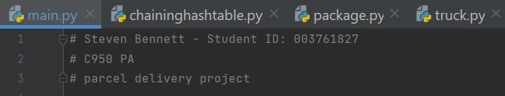

# C2. Process and Flow Comments

Completed

# D. Data Structure

A self-adjusting data structure in this program is a chaining hash table. Package objects are created from the datapoints in the hash table and are eventually filtered and selected by the Nearest Neighbor algorithm shortest_distance to efficiently load the trucks and route the truck.

# D1. Explanation of Data Structure

The hash table accounts for the datapoints by storing them as package objects. The package objects are accessed by passing the package ID as the argument in the search function found in chaininghashtable.py. Once the search function returns the package object, the attributes for each package object can be accessed using typical object-oriented programming techniques. Package objects can also be removed or inserted using the remove and insert functions, respectively.

# E. Hash Table

Completed. Please refer to the class ChainingHashTable in chaininghashtable.py.

# F. Look-Up Function

Completed. Please refer to the search function under the class ChainingHashTable in chaininghashtable.py.

# G. Interface

A command line UI is provided. Please refer to wgups_package_tracker found in main.py

# G1. First Status Check

Screenshots of status between 8:35am and 9:25am:

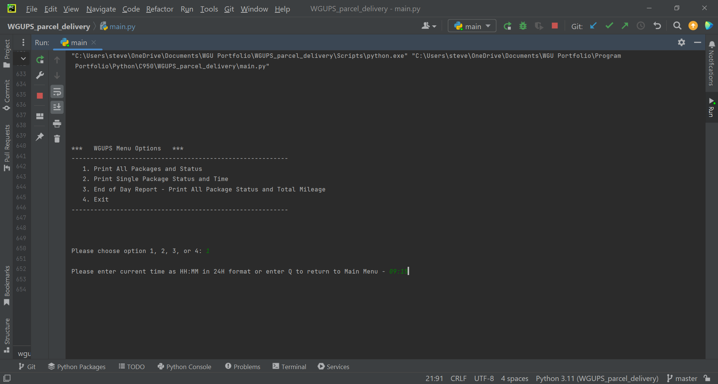



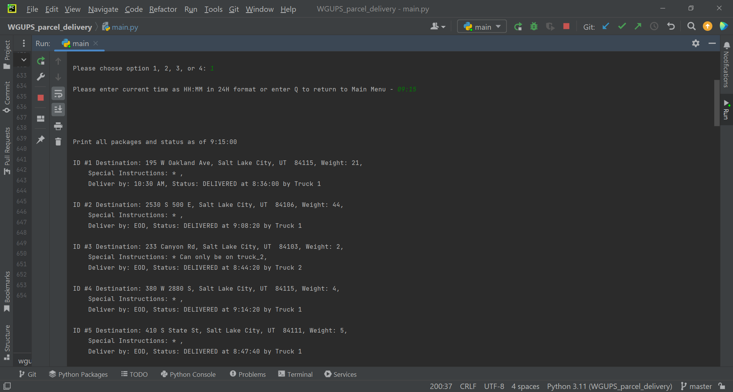

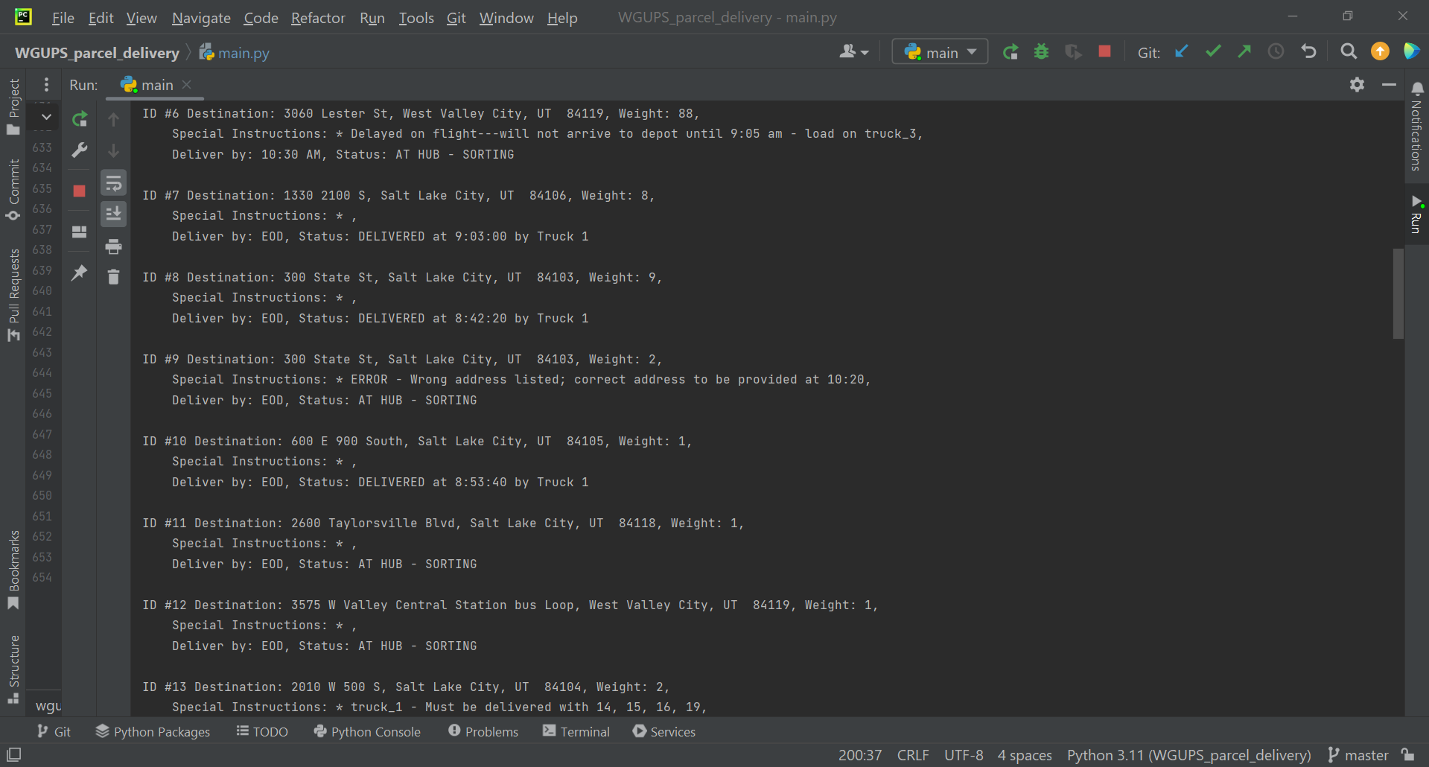

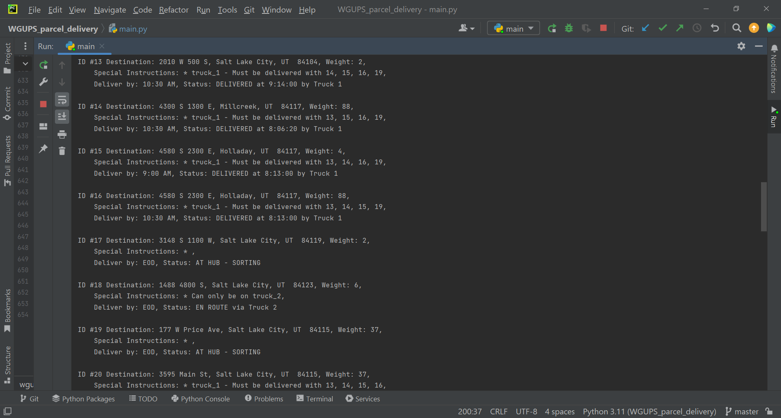

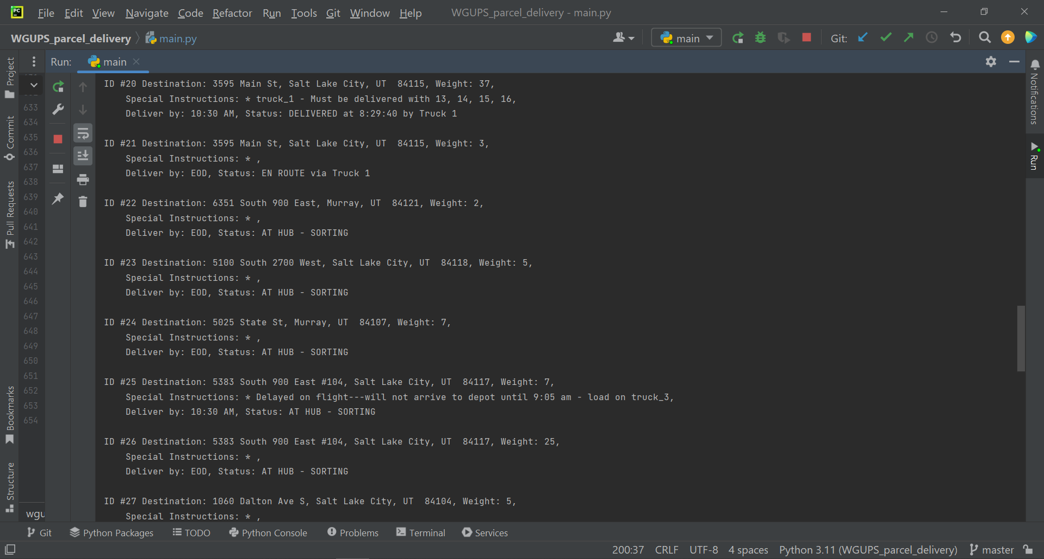

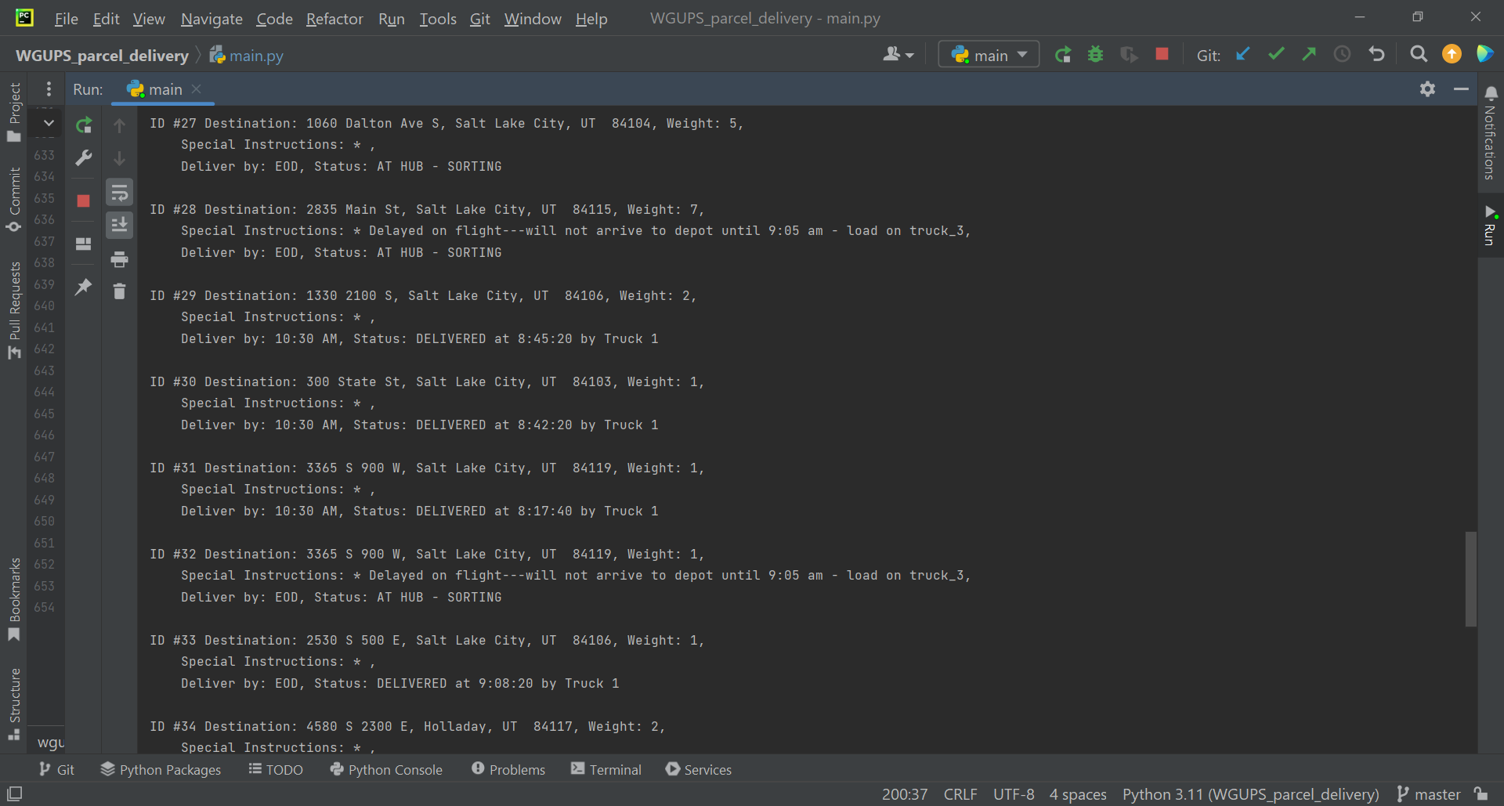

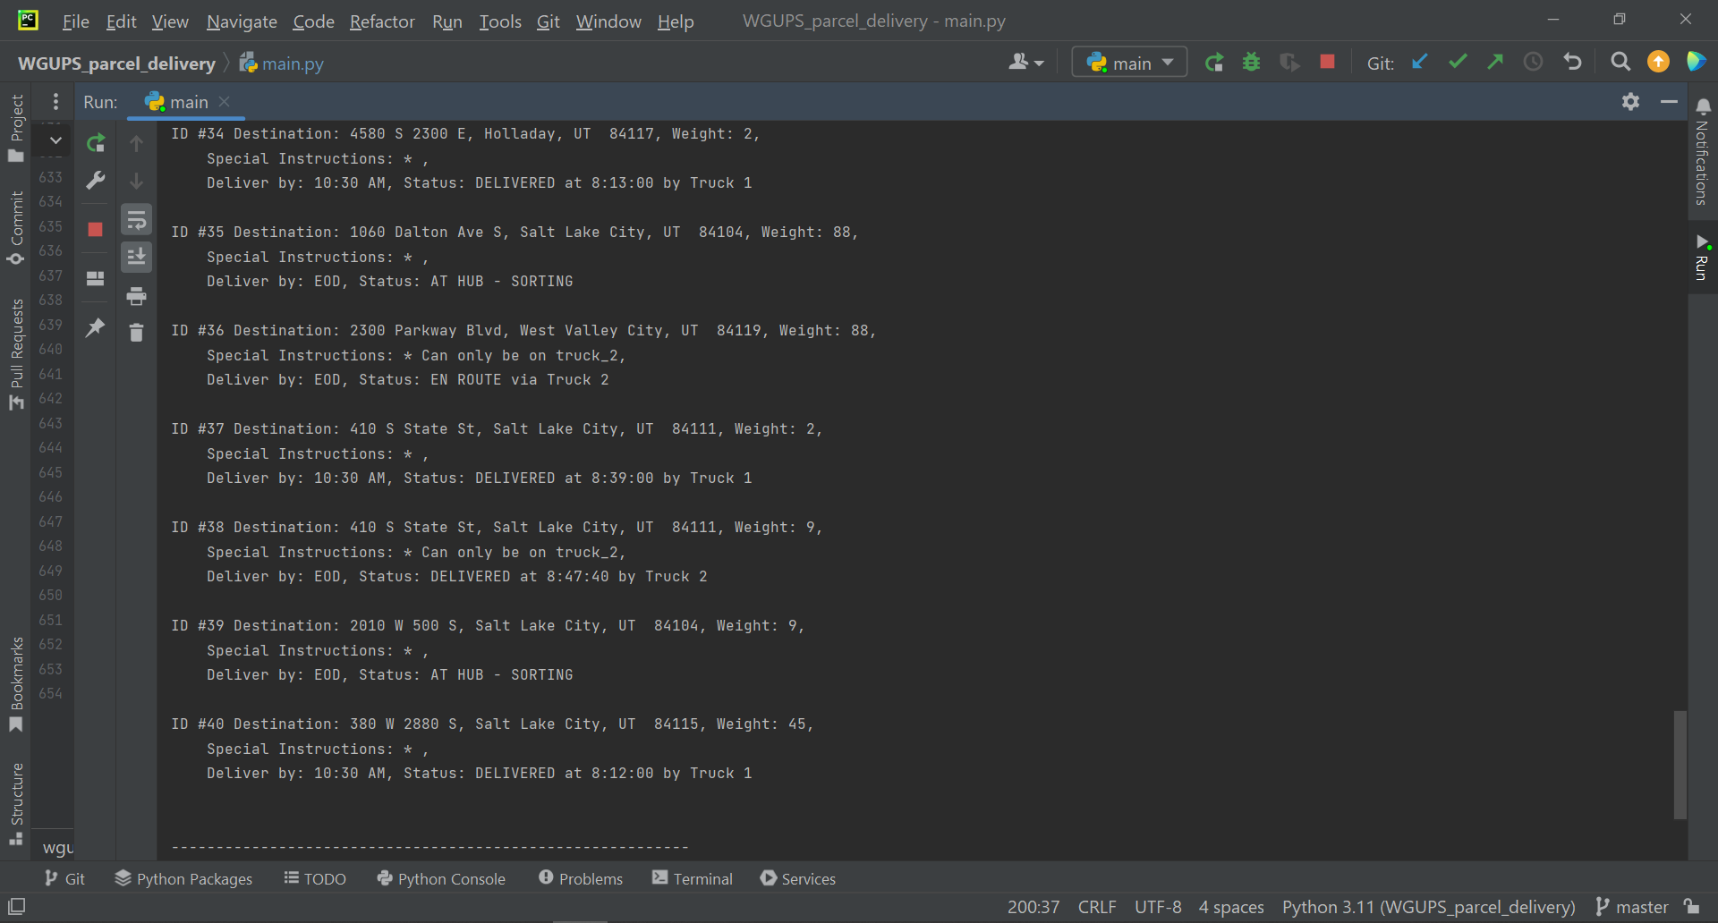

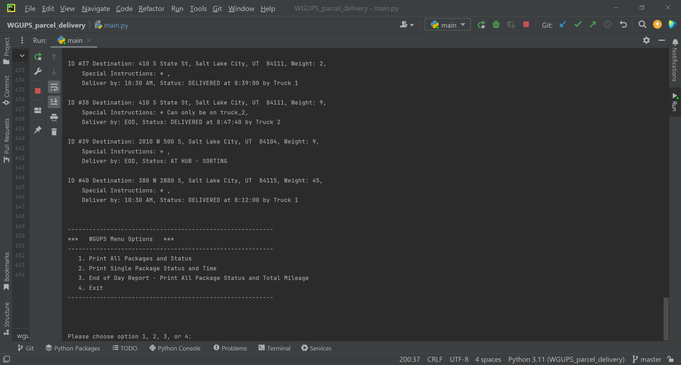

# G2. Second Status Check

Screenshot of status between 9:35am and 10:25am:

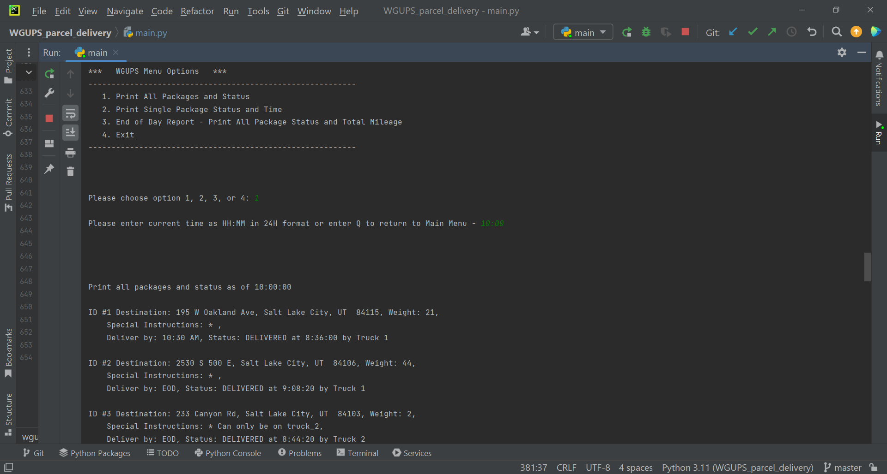

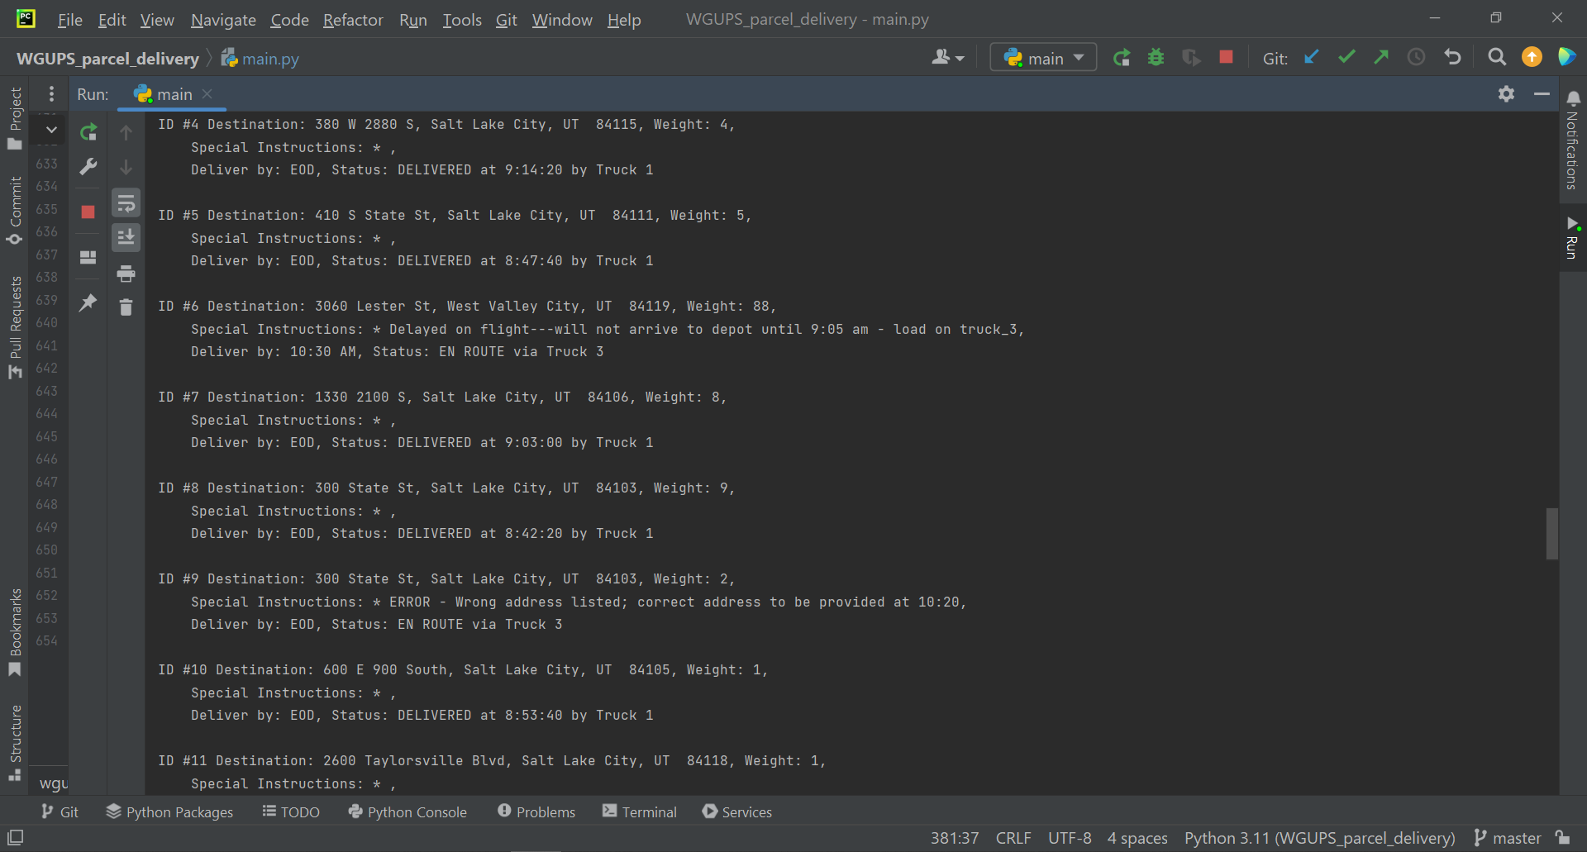

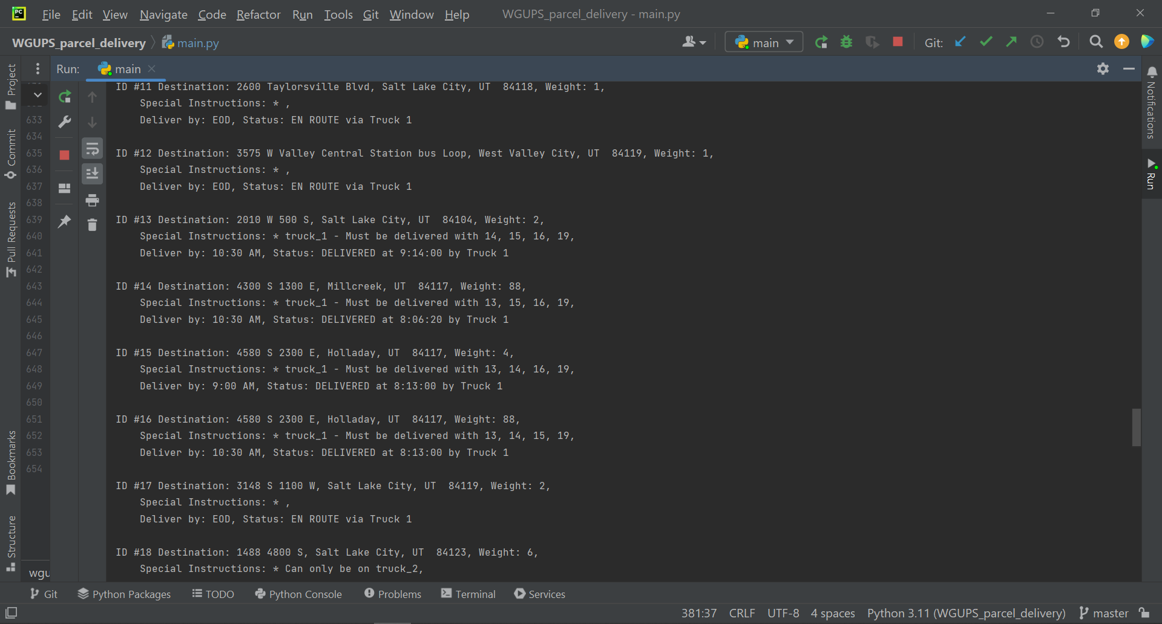

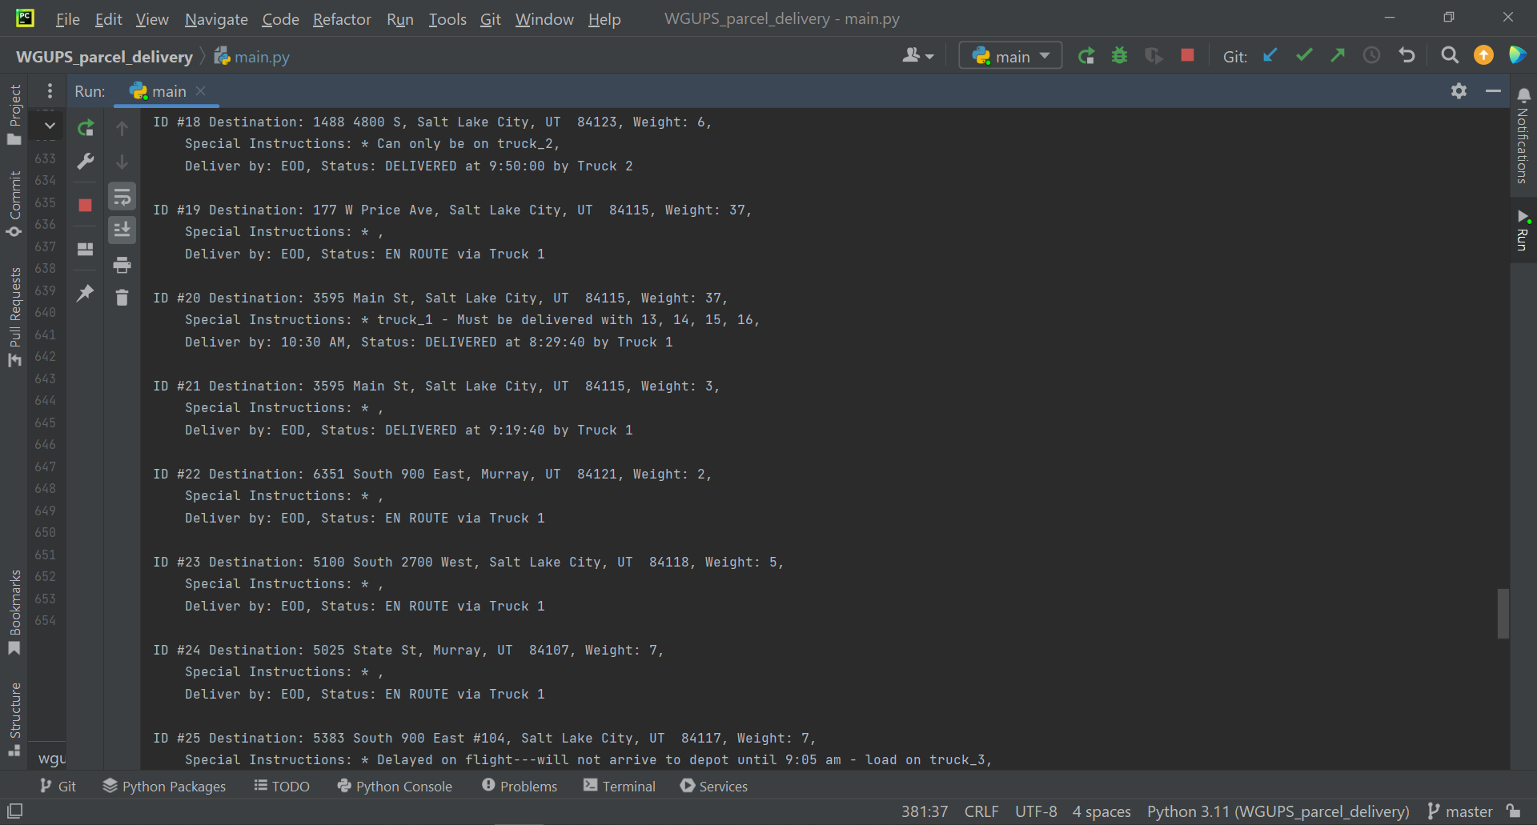

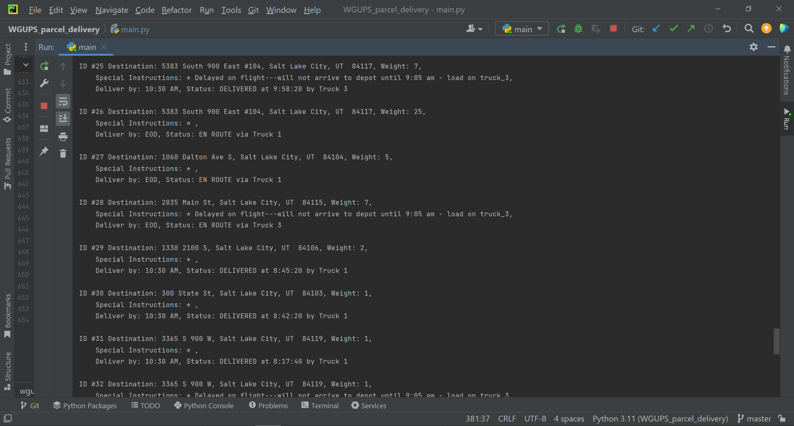

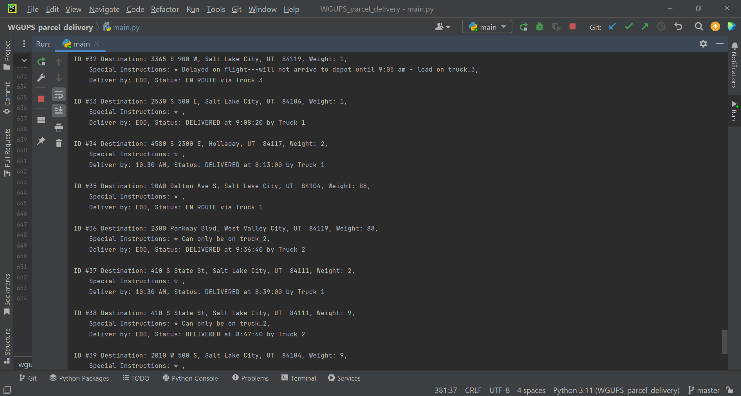

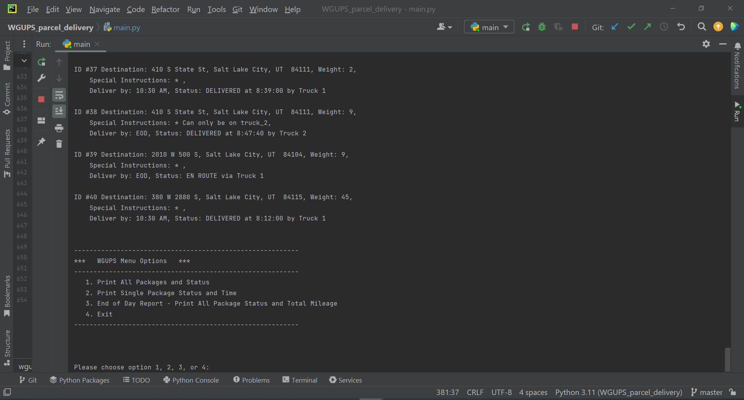

# G3. Third Status Check

Screenshot of status between 12:03pm and 1:12pm:

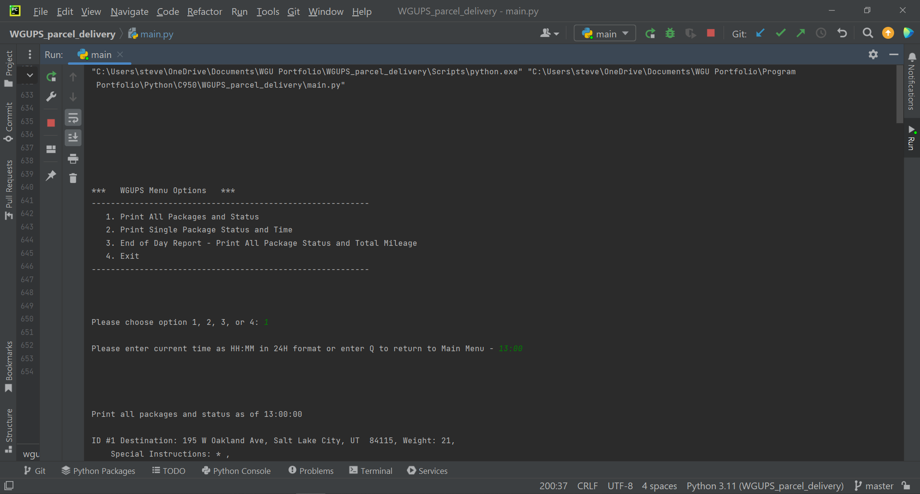

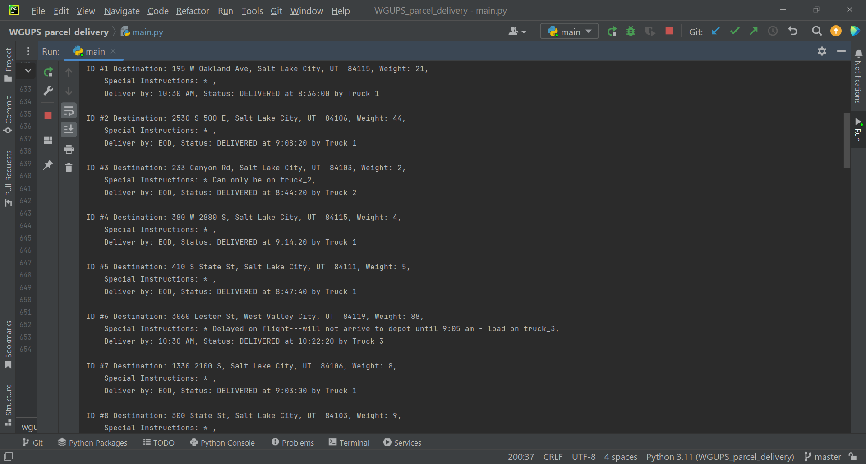

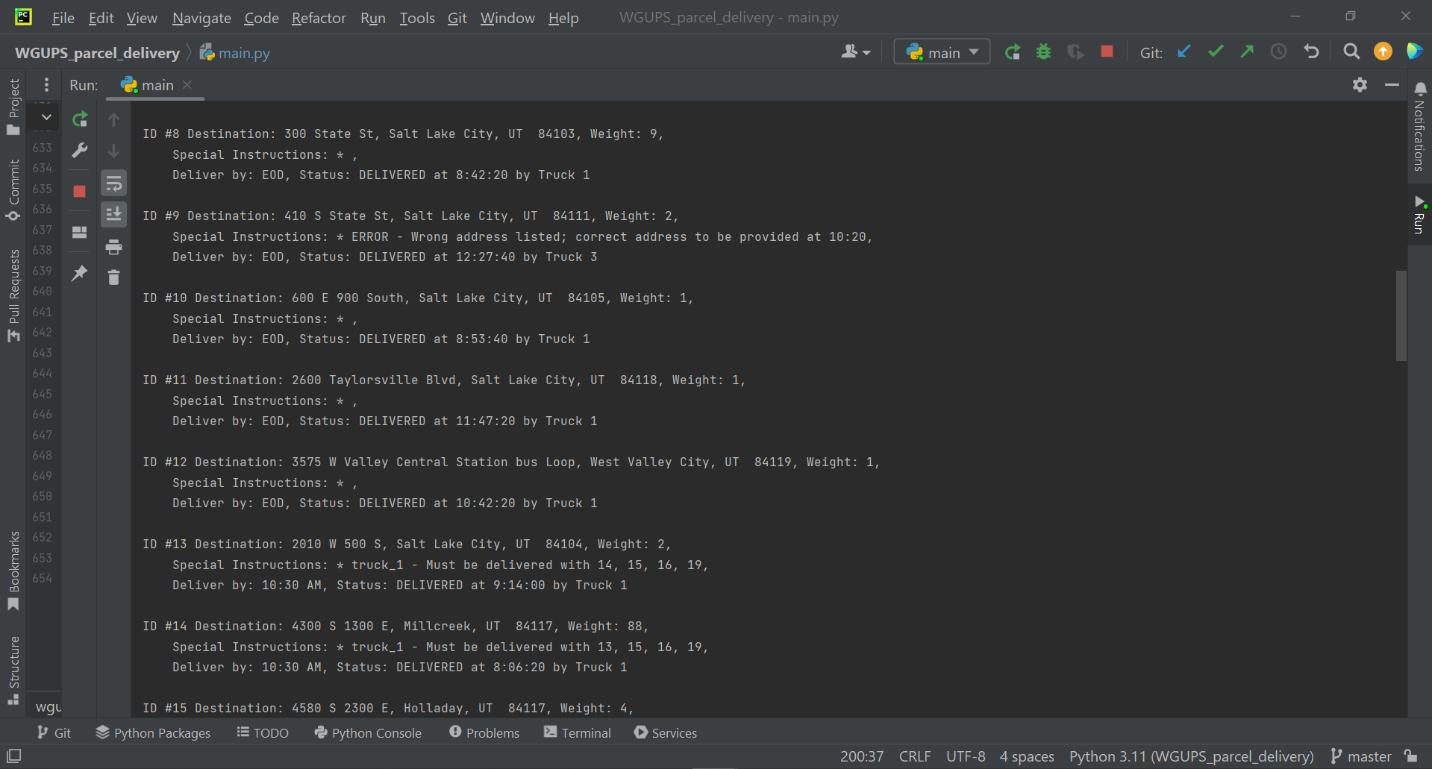

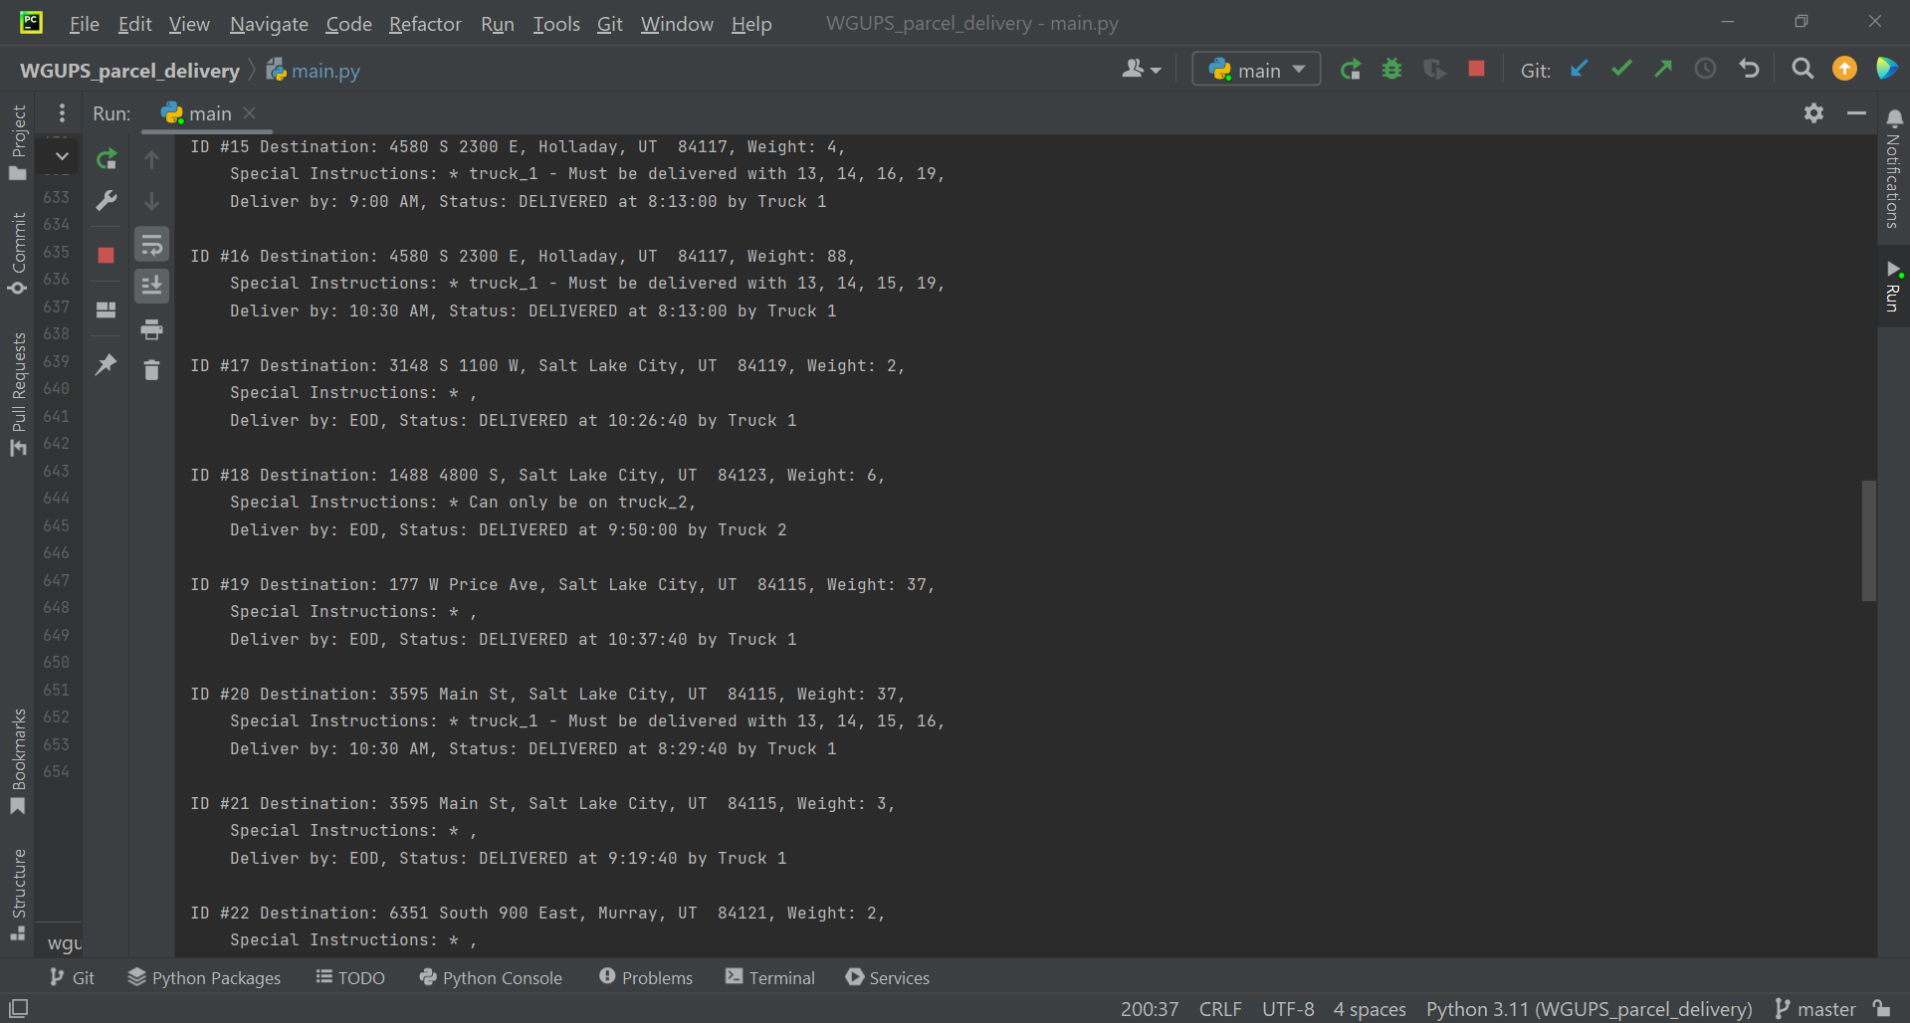

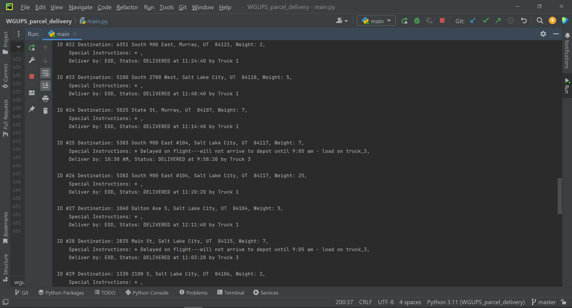

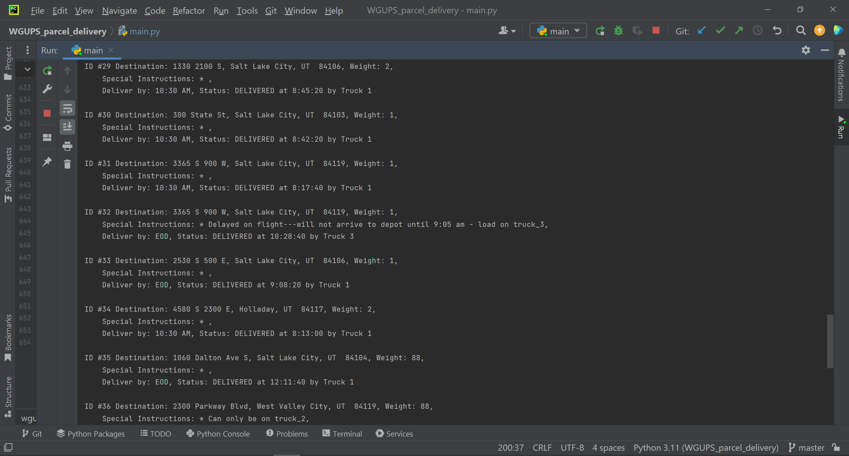

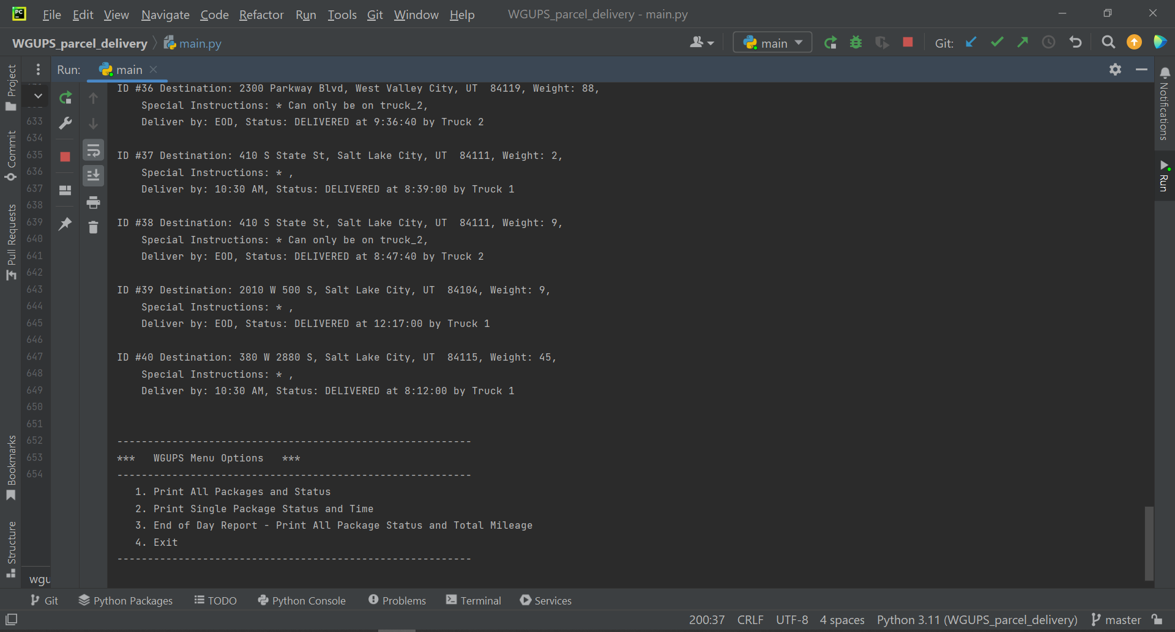

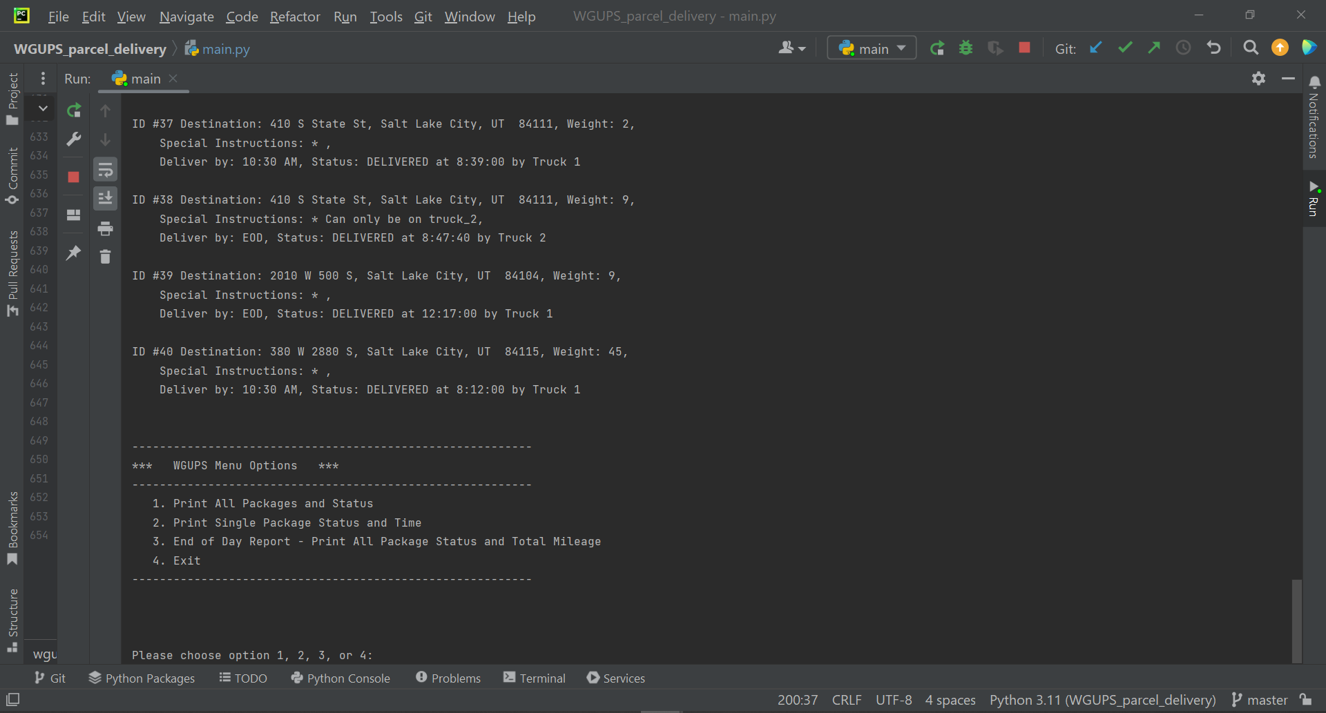

# H. Screenshots of Code Execution

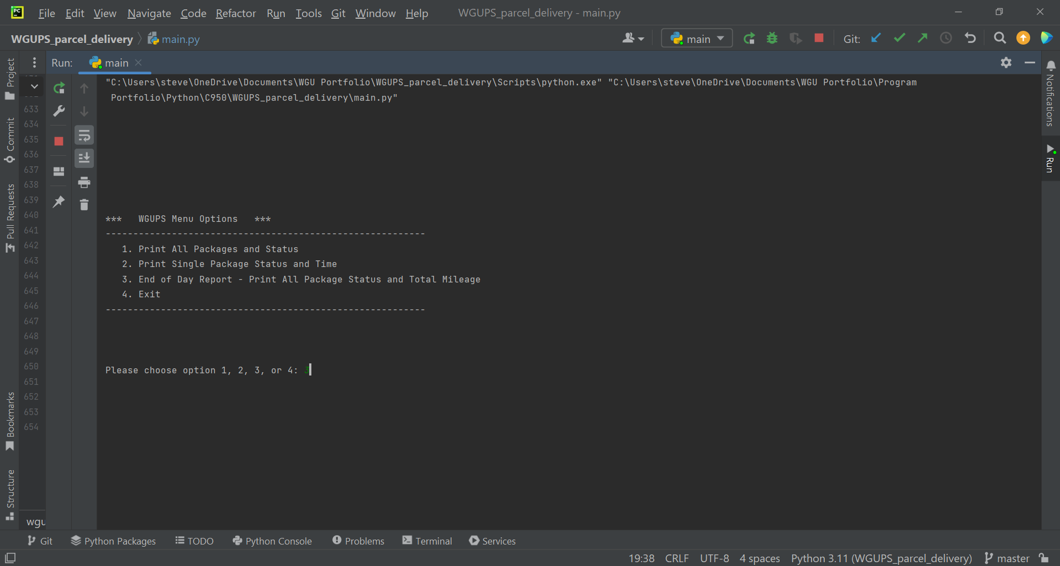



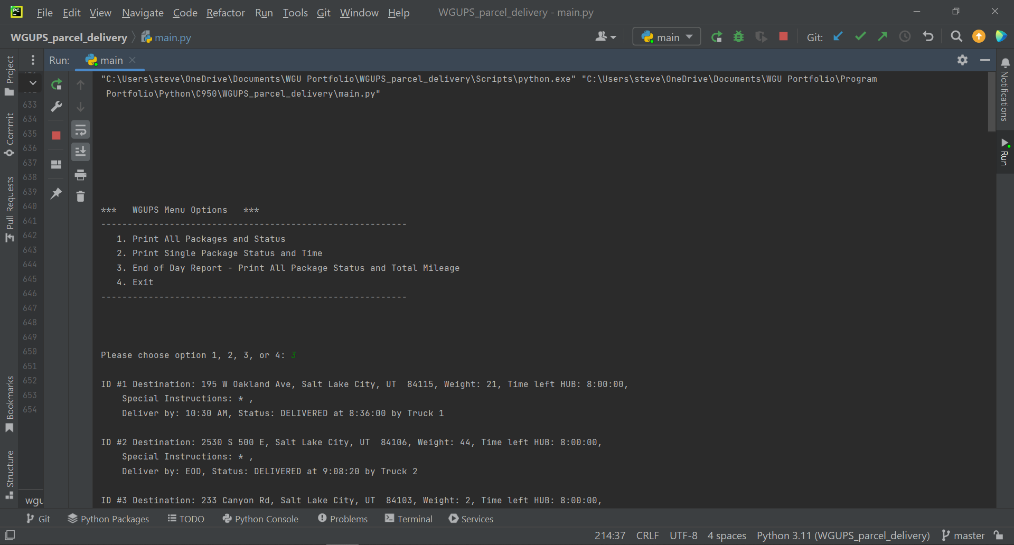

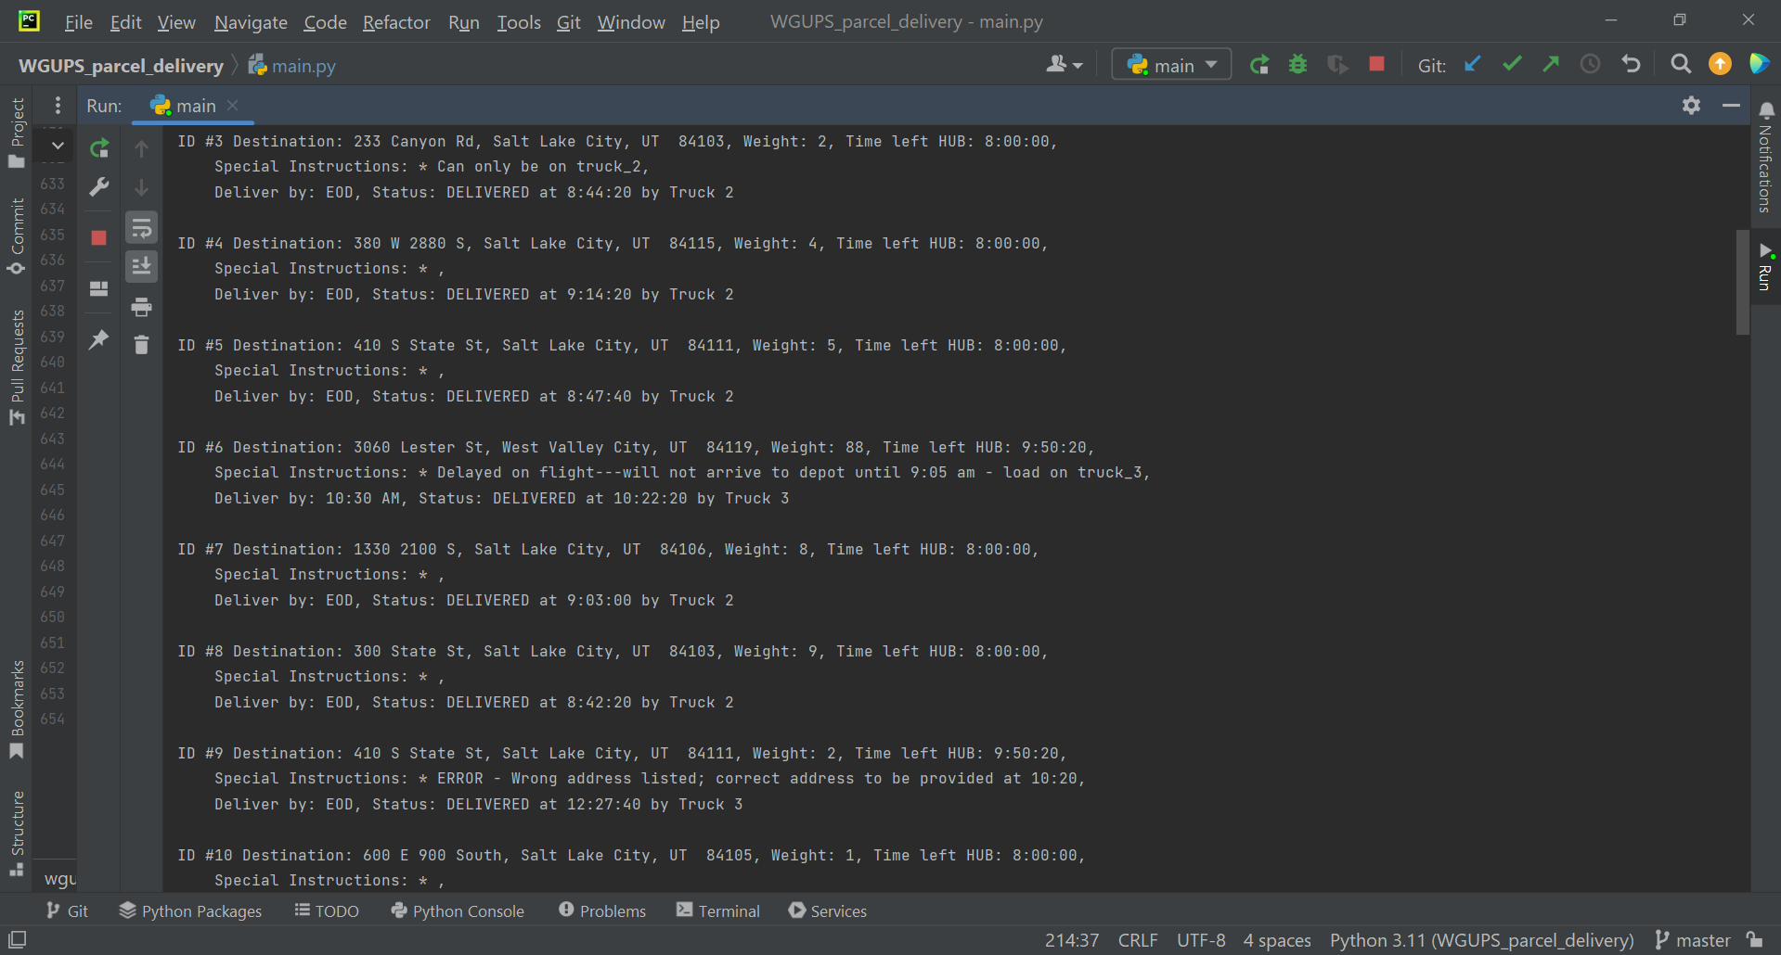

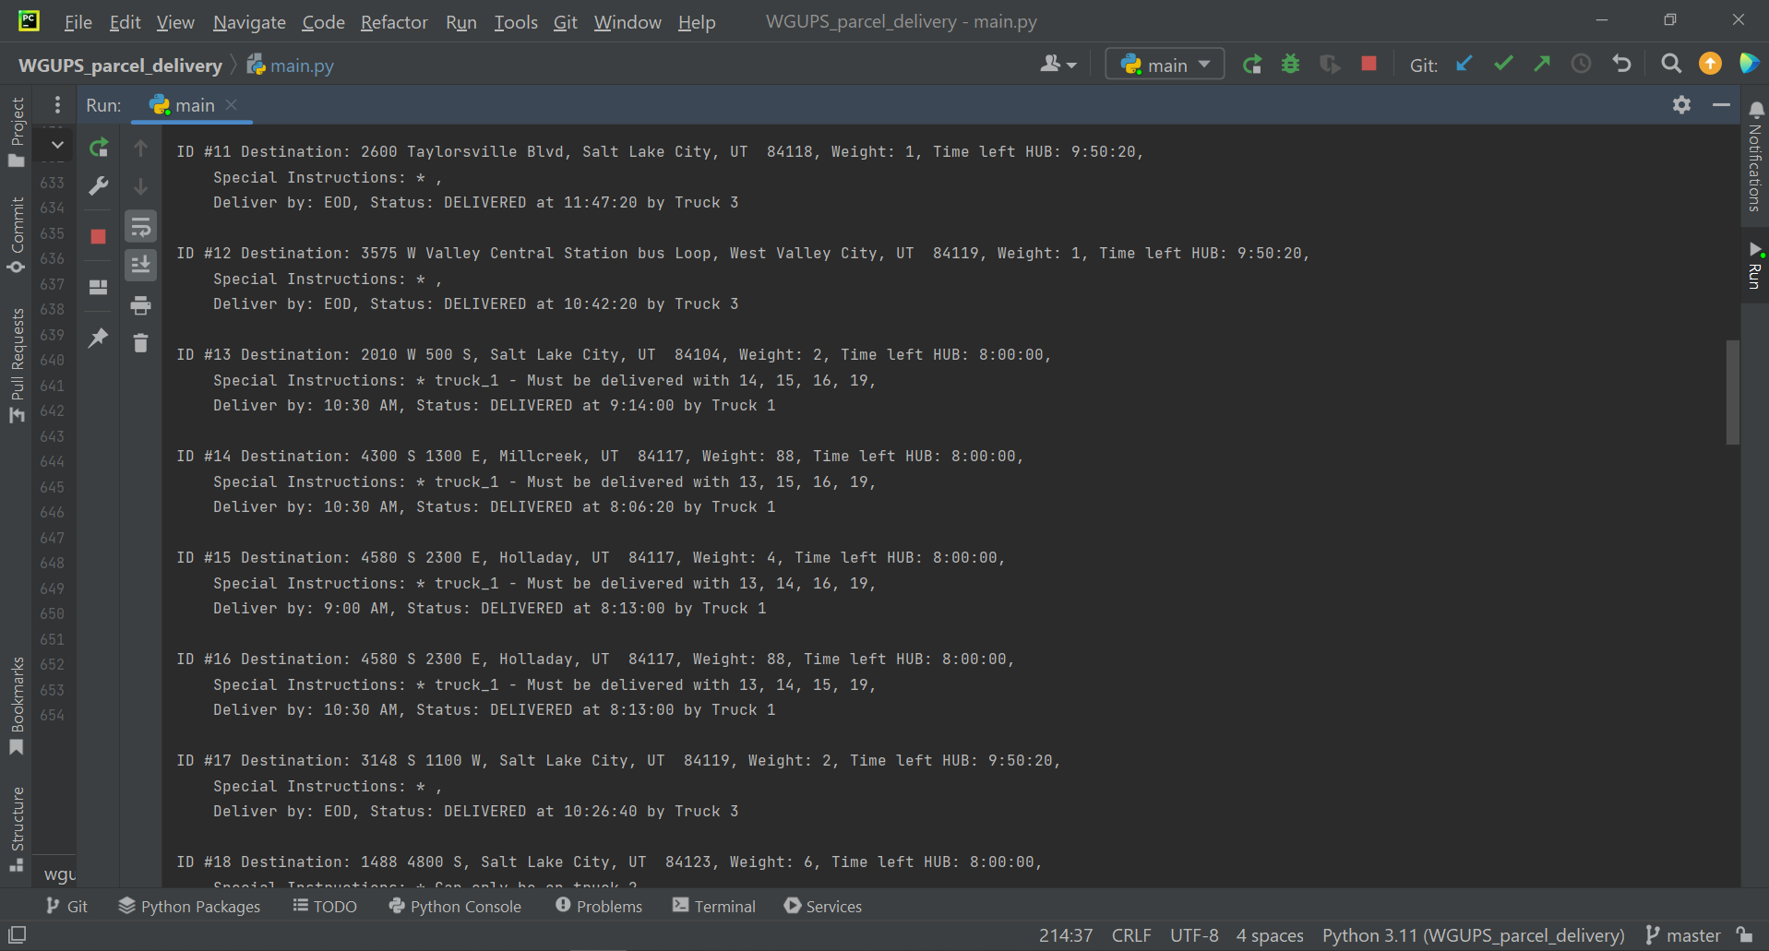

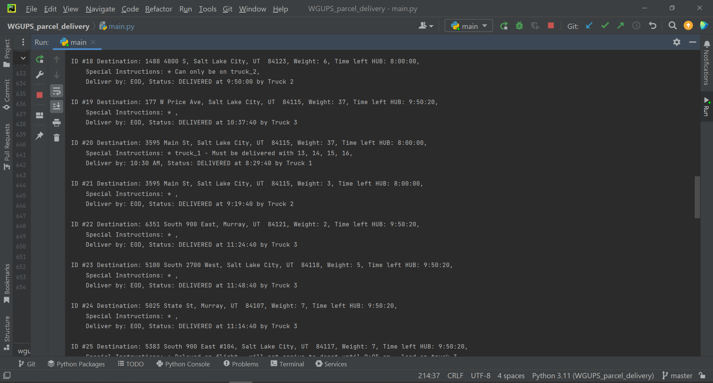

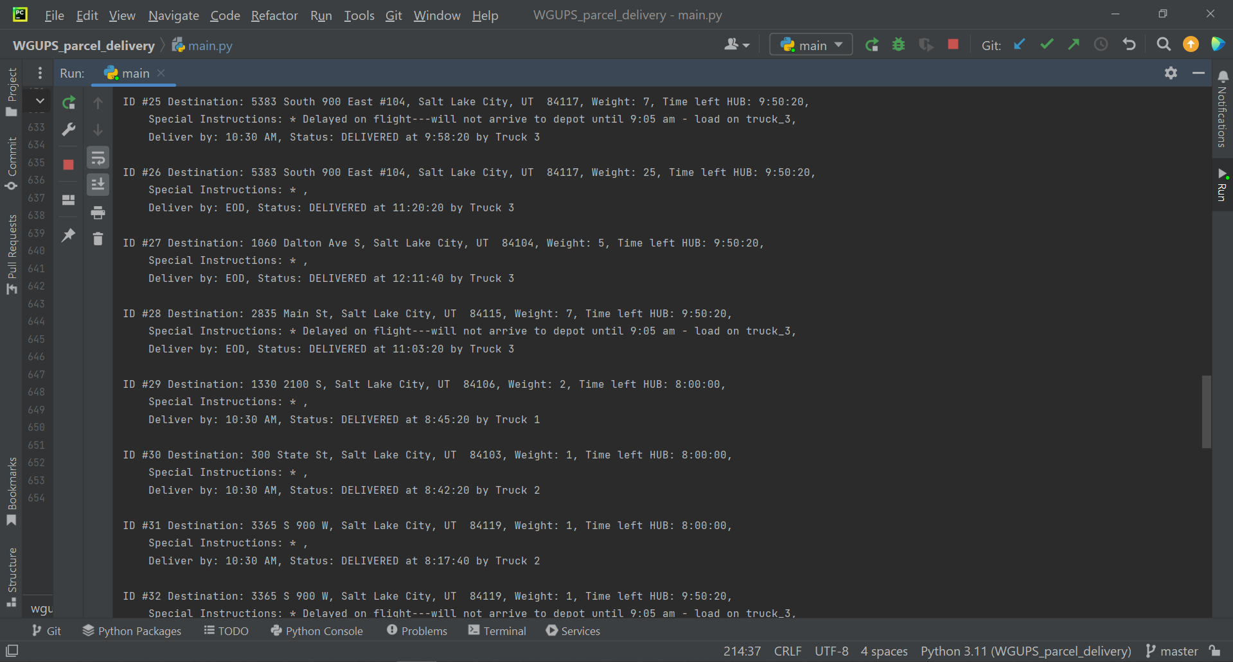

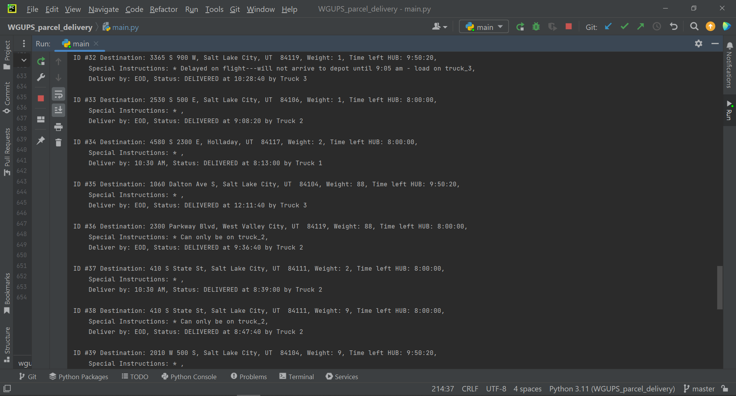

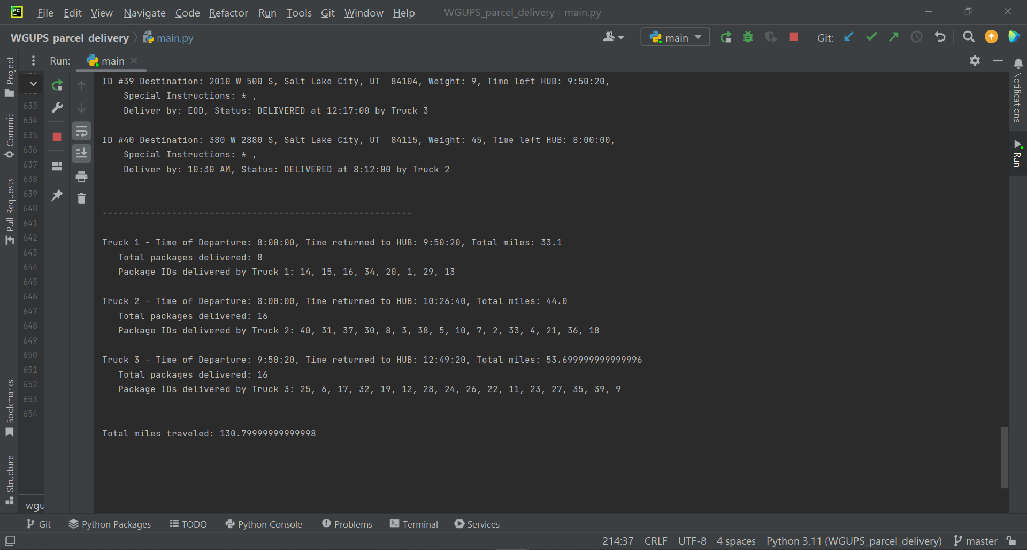

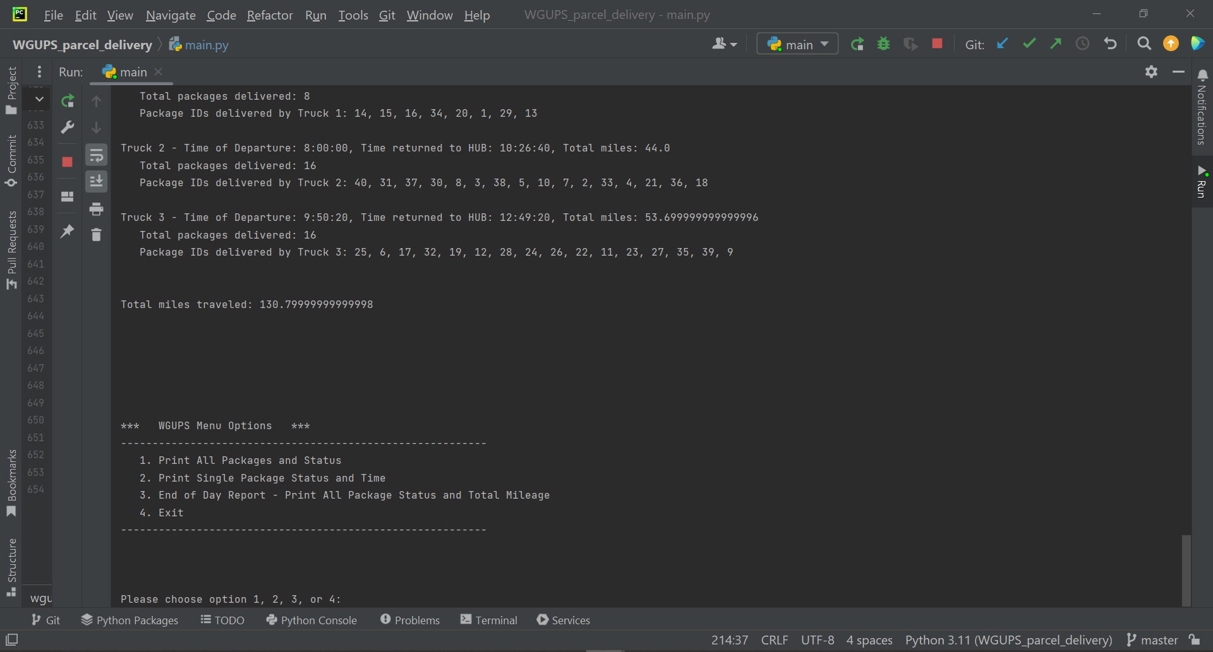

# I1. Strengths of Chosen Algorithm

**Accuracy**: The shortest_distance function (based on the Nearest Neighbor algorithm) executes without error and enables the program to fulfill all delivery requirements. All packages were delivered prior to the delivery deadline and on the requested truck if specified. Total mileage for all trucks is under 140 miles. The status of each package is updated appropriately at each major step.

**Adaptability**: The algorithm is able to adapt to any changes in the package data and is minimally affected by the number of packages, trucks, or destinations as Big O = O(N). It has been refined to decrease the demand on hardware resources and speed up run time.

# I2. Verification of Algorithm

The verification of this program meeting all requirements can be found in the highlighted sections in the following screenshots:



































# I3. Other possible Algorithms

Other possible algorithms that could meet the requirements and could have been incorporated in lieu of a Nearest Neighbor Algorithm are the Nearest Insertion algorithm and the Dijkstra algorithm.

# I3A. Algorithm Differences

**Dijkstra** – This option picks the shortest path in a weighted graph between two vertices. It picks a source vertex (for this case it would be the HUB) and adds each qualifying vertex to a set of vertices. Each vertex is sorted by the distance from the source to maintain queue prioritization. While the Dijkstra algorithm could result in decreased total mileage, the source data provided did not utilize a weighted graph. Distance data is provided in the form of a CSV file (converted from excel), making Nearest Neighbor a better choice with my current skillset. (“Dijkstra’s Algorithm,” (n.d.) Retrieved 3/19/2023 from Wikipedia <https://en.wikipedia.org/wiki/Dijkstra%27s_algorithm>)

**Nearest Insertion** – The Nearest Insertion algorithm starts with two addresses and adds them to a route. It searches for the next closest address to any address in the route, then adds it to the route. This process repeats until there are no more addresses to visit (or when the truck is full in this case). Nearest Neighbor starts at 1 address and builds a route from there. With my current skillset, I chose Nearest Neighbor because I felt it would be easier to prioritize package delivery based on early delivery times and constraints in the package data special instructions.

(Weru, Lawrence. “11 Animated Algorithms for the Traveling Salesman Problem,” (n.d.) Retrieved 3/19/2023 from stemlounge.com <https://stemlounge.com/animated-algorithms-for-the-traveling-salesman-problem/>)

# J. Different Approach

In hindsight, If I were to recreate this project, I would have separated my functions into a larger number of files. This would have increased the readability of main.py, especially for those with a smaller display. I could also reuse those files for future projects as needed. Instead of returning an address, I may have chosen to have the shortest_distance algorithm return a list comprised of packages in the order of which they were to be delivered most efficiently (heuristically speaking). Then the deliver_packages algorithm could have popped the package object from the list.

# K1. Verification of Data Structure

In this example, the hash table was able to successfully be the primary data structure. All packages were delivered on time and according to the special instructions. The maximum allowable total mileage (140 miles) was not exceeded. This example completed the deliveries as required in 130.8 miles. The data structure is self-adjusting and efficient and comes complete with search, insert, and remove functions. The UI provides timely and accurate reports.

# K1A. Efficiency

The search algorithm for the hash table in chaininghashtable.py has a Big O complexity of O(N). N will vary depending on the number of packages to be delivered. As the number of packages increases, the space-time complexity will experience a linear increase.

# K1B. Overhead

The hash table space usage is affected by changes in the number of packages in a linear fashion. As the number of packages fluctuates, the hash table grows to accommodate any number of package objects created. In simple terms, it matches the size requirements of the number of packages automatically.

# K1C. Implications

Changes to the number of trucks or cities would have little to no effect the space-time complexity of the lookup function (search in chaininghashtable.py). The number of attributes in the package object would (most likely) remain the same. The Big O of O(N) would still be accurate.

# K2. Other Data Structures

Other data structures that could have been implemented and still meet the requirements: a dictionary and an AVL tree.

# K2a. Data Structure Differences

A dictionary uses an unordered key:value structure that would decrease the time complexity of the lookup function (see search in chaininghashtable.py) from O(N) to O(1). This would be accomplished by using the package ID as the key and incorporating square bracket notation in the lookup function. Since the key must be unique, it would prevent repeated entries. Square bracket notation is not a valid method to access a hash table.

An AVL tree may be a good data structure candidate for this project. An AVL tree implements a binary search tree. The data can be sorted in an AVL tree to improve tree traversal. Hash tables are not able to be sorted. Hash tables excel in faster search times at the cost of memory usage. An AVL tends to have memory usage that is more proportional to the number of elements stored.

# M. Professional Communication

# L. Sources - Works Cited

“Dijkstra’s Algorithm,” (n.d.) Retrieved 3/19/2023 from Wikipedia

<https://en.wikipedia.org/wiki/Dijkstra%27s_algorithm>

Weru, Lawrence. “11 Animated Algorithms for the Traveling Salesman Problem,” (n.d.)

Retrieved 3/19/2023 from stemlounge.com

<https://stemlounge.com/animated-algorithms-for-the-traveling-salesman-problem/>